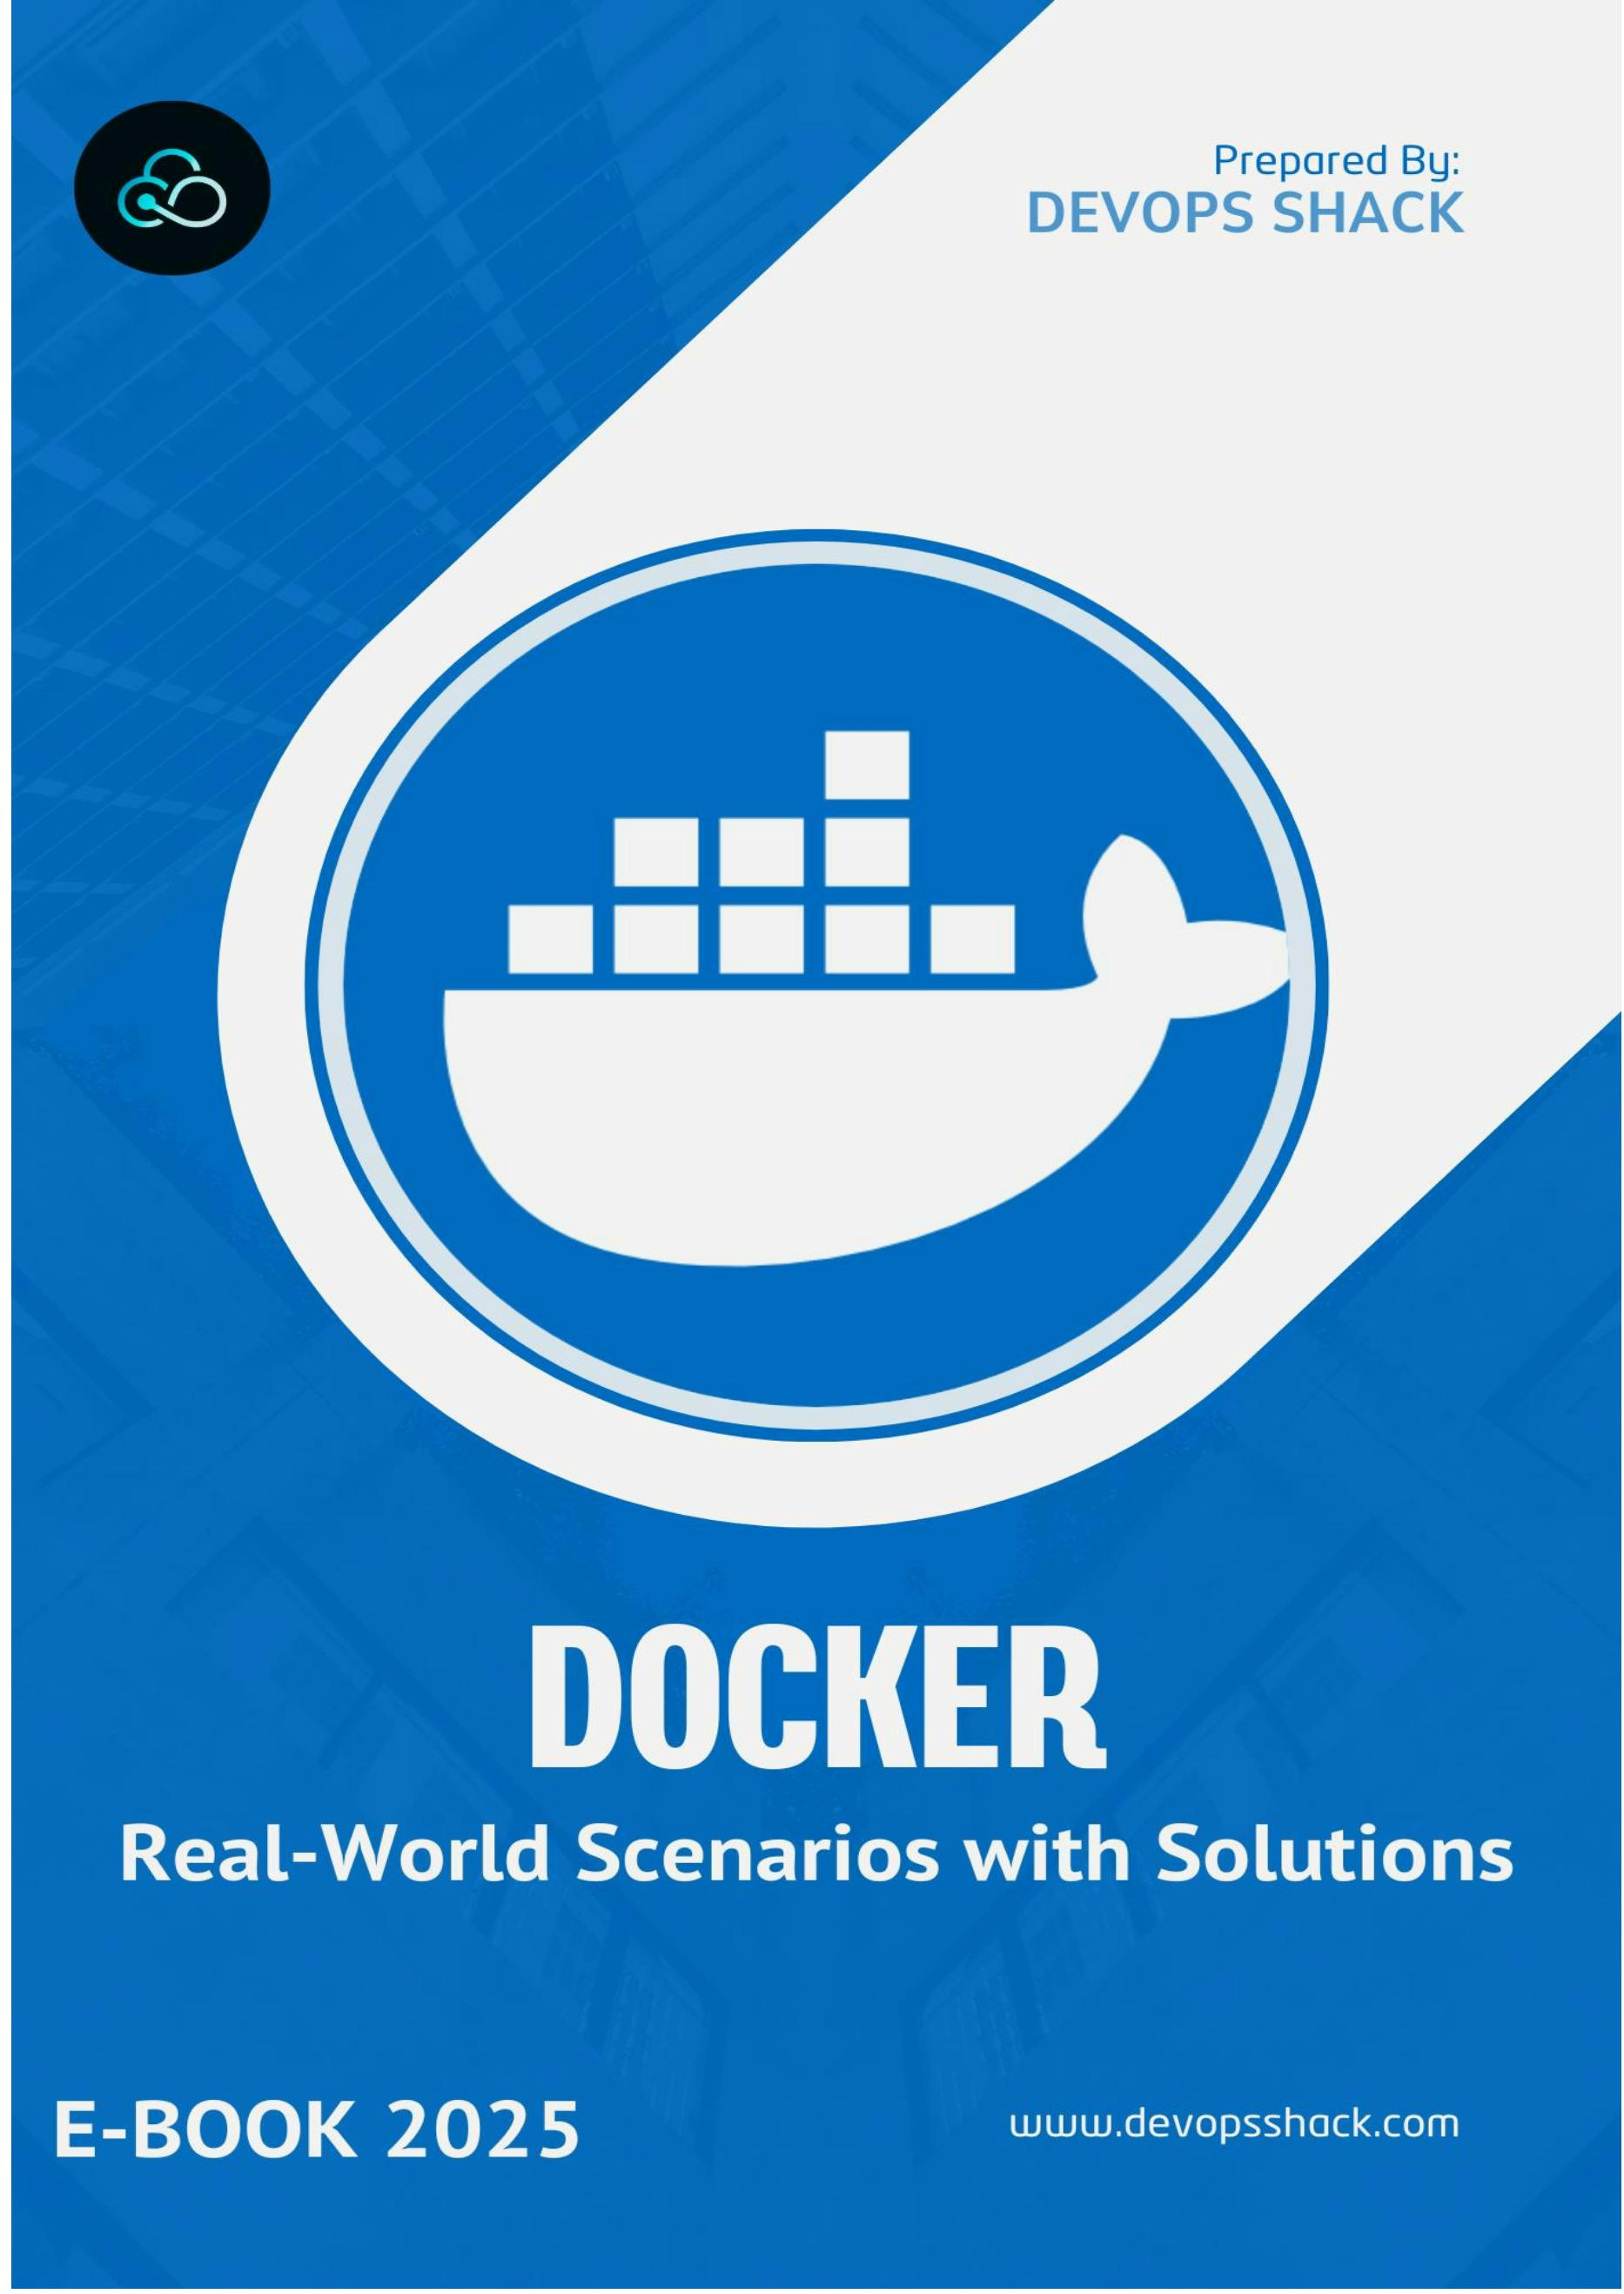

Click here for DevSecOps & Cloud DevOps Course
DevOps Shack
Mastering Docker: Real-World Scenarios with
Soluꢀons
Table of Contents
1–10: Basic Debugging and Opꢀmizaꢀon
1. Debugging a container that fails to start.
2. Handling a non-existent volume during binding.
3. Reducing Docker image size.
4. Passing sensiꢀve data securely to containers.
5. Troubleshooꢀng network issues between containers.
6. Managing disk space for containers.
7. Ensuring containers restart automaꢀcally on failure.
8. Updaꢀng a containerized applicaꢀon without downꢀme.
9. Debugging Dockerﬁle build failures.
10.Persisꢀng data in a stateless Docker container.
11–20: Advanced Conﬁguraꢀon and Mulꢀ-Container Management
11.Connecꢀng a container to mulꢀple networks.
12.Seꢁng resource limits for containers.
13.Sharing environment variables across containers.
14.Running mulꢀple versions of the same applicaꢀon.
15.Troubleshooꢀng high CPU usage in containers.
16.Building mulꢀ-stage Dockerﬁles.
17.Running containers with limited network access.
2
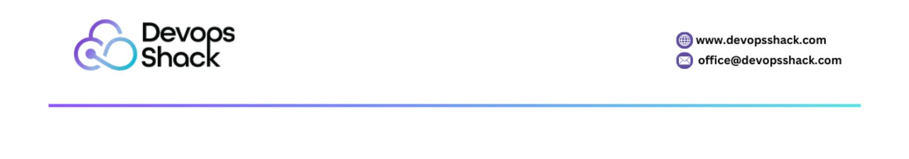

18.Rolling back to a previous Docker image version.
19.Migraꢀng data between Docker volumes.
20.Monitoring logs across mulꢀple containers.
21–30: Network, Security, and Resource Management
21.Conﬁguring speciﬁc DNS servers for containers.
22.Restricꢀng access to a container on a speciﬁc IP.
23.Conﬁguring container logging.
24.Restarꢀng containers automaꢀcally with delay.
25.Prevenꢀng data loss during container recreaꢀon.
26.Managing mulꢀple versions of Docker Compose ﬁles.
27.Scaling services in Docker Compose.
28.Exposing Docker services securely to the internet.
29.Inspecꢀng the ﬁlesystem of a running container.
30.Cleaning up unused Docker objects.
31–40: Operaꢀonal Challenges and Opꢀmizaꢀon
31.Running a container with a speciﬁc DNS conﬁguraꢀon.
32.Restricꢀng access to containers on speciﬁc IPs.
33.Handling containers consuming too much memory.
34.Running a container in detached mode and reaꢂaching later.
35.Limiꢀng the number of processes inside a container.
36.Restarꢀng containers with updated environment variables.
37.Ensuring containers start automaꢀcally on system boot.
38.Securing containers running sensiꢀve applicaꢀons.
39.Connecꢀng a container to a running database container.
40.Versioning Docker images in CI/CD pipelines.
3


41–50: Advanced Scenarios, Security, and Deployment
41.Running a container in privileged mode.
42.Managing mulꢀple containers with diﬀerent conﬁguraꢀons in Docker
Compose.
43.Debugging slow container startup ꢀmes.
44.Cleaning up exited containers automaꢀcally.
45.Implemenꢀng health checks in containers.
46.Backing up and restoring Docker volumes.
47.Deploying a mulꢀ-ꢀer applicaꢀon using Docker Compose.
48.Handling secrets securely in Docker Compose.
49.Running containers with GPU support.
50.Securing Docker images before deployment.
4
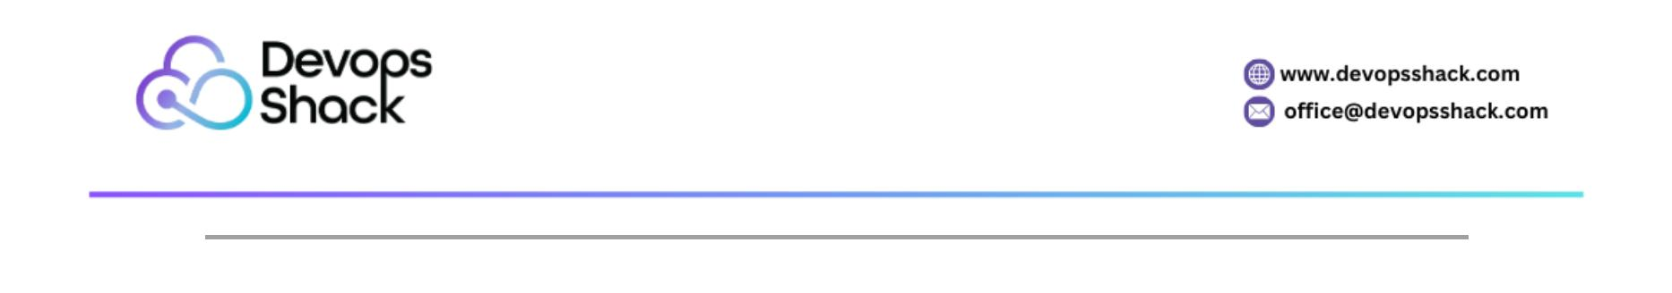

Introducꢀon to Docker Scenarios
Docker has become a cornerstone technology for modern soﬅware
development and deployment, enabling teams to build, ship, and run
applicaꢀons in consistent, portable environments. However, working with
Docker in real-world scenarios oﬅen presents challenges that go beyond basic
usage. From debugging failing containers to implemenꢀng secure deployments,
these challenges require a solid understanding of Docker's features and best
pracꢀces.
This document presents 50 scenario-based quesꢀons and answers to help
developers, DevOps engineers, and system administrators navigate common
and advanced Docker challenges. Each scenario is designed to replicate real-
world issues and provides detailed soluꢀons to equip you with the knowledge
needed to troubleshoot, opꢀmize, and scale containerized applicaꢀons
eﬀecꢀvely.
The scenarios are categorized into themes such as debugging, resource
management, security, network conﬁguraꢀon, and deployment strategies.
Whether you’re a beginner looking to strengthen your foundaꢀonal skills or an
experienced pracꢀꢀoner seeking advanced ꢀps, this collecꢀon will guide you
through the intricacies of Docker.
By exploring these scenarios, you will:
•
•
Learn to troubleshoot and opꢀmize containerized environments.
Gain pracꢀcal insights into handling Docker-related complexiꢀes in
producꢀon.
•
Understand best pracꢀces for secure and eﬃcient Docker usage.
Dive into these scenarios to enhance your experꢀse and ensure your Docker
workﬂows are robust, scalable, and ready to tackle real-world challenges.
Basic Debugging and Opꢀmizaꢀon
1. How do you debug a container that is failing to start?
Answer:
•
Use the docker logs command to check the container's logs:
5
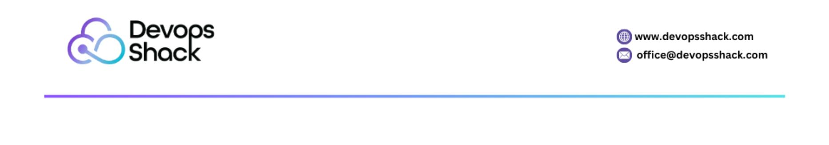

docker logs <container_id>
•
If the container exits immediately, use the --tail and --follow opꢀons to
monitor the logs.
•
Start the container in an interacꢀve shell to invesꢀgate:
docker run -it <image_name> /bin/bash
•
•
•
Check the Dockerﬁle for potenꢀal misconﬁguraꢀons like incorrect entry
points.
Use docker inspect <container_id> to check the container's
conﬁguraꢀon.
Debug startup commands using CMD or ENTRYPOINT by overriding
them:
docker run -it <image_name> /bin/bash
2. What happens if you bind a volume that doesn’t exist on the host?
Answer:
•
If the volume path doesn’t exist, Docker will automaꢀcally create a
directory at the speciﬁed path on the host.
•
Example:
docker run -v /nonexistent:/app alpine
This will create /nonexistent on the host system.
•
•
The default permissions will depend on the user running Docker.
It is a best pracꢀce to ensure the directory exists with proper
permissions before running the container.
3. How do you reduce the size of a Docker image?
Answer:
1. Use smaller base images like alpine:
FROM alpine:latest
6
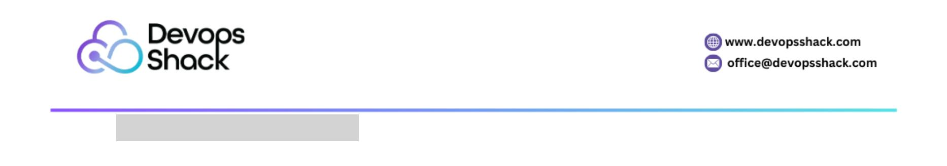

2. Minimize the number of layers by combining commands:
RUN apt-get update && apt-get install -y \
curl \
vim && \
apt-get clean
3. Remove unnecessary ﬁles in the same layer:
RUN rm -rf /var/lib/apt/lists/*
4. Use .dockerignore to exclude ﬁles from the build context.
4. How do you pass sensiꢀve data to a Docker container securely?
Answer:
•
Use Docker secrets:
1. Create a secret:
echo "my-secret-password" | docker secret create db_password -
2. Use the secret in a Docker service:
docker service create --name my-service --secret db_password alpine
•
Pass environment variables securely with docker-compose:
version: '3.7'
services:
app:
image: my-app
environment:
- SECRET_KEY=${SECRET_KEY}
Use .env to store sensiꢀve values and ensure it’s excluded in .giꢀgnore.
5. How do you troubleshoot network issues between Docker containers?
7
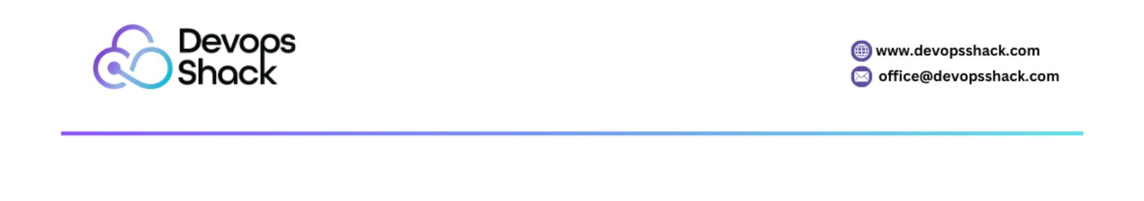

Answer:
1. Check the network conﬁguraꢀon:
docker network inspect <network_name>
2. Verify container connecꢀvity using ping:
docker exec <container_id> ping <another_container>
3. Ensure both containers are on the same network.
4. Examine ﬁrewall rules and port mappings.
5. Use curl or telnet to test speciﬁc ports:
docker exec <container_id> curl hꢂp://<other_container>:<port>
6. How do you handle a container running out of disk space?
Answer:
•
Check disk usage:
docker system df
•
Prune unused resources:
docker system prune -a --volumes
•
Clean unused images:
docker image prune -a
•
Mount volumes to avoid wriꢀng large ﬁles in the container's ﬁlesystem.
7. How do you ensure a container restarts automaꢀcally if it crashes?
Answer:
•
Use the --restart policy:
docker run --restart always <image_name>
•
Available restart policies:
o no: Default, no automaꢀc restart.
8
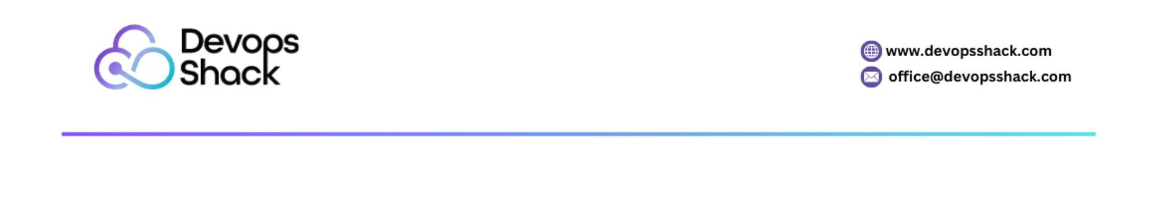

o on-failure: Restart only if the container exits with a non-zero
status.
o always: Restart regardless of exit status.
o unless-stopped: Restart unless the container is manually stopped.
8. How do you update an applicaꢀon running in a container without
downꢀme?
Answer:
•
Use a rolling update strategy with docker-compose:
version: '3.9'
services:
app:
image: my-app:latest
deploy:
update_conﬁg:
parallelism: 2
delay: 10s
•
Replace the running container:
docker-compose up -d --no-deps --build app
9. How do you debug a build failure in a Dockerﬁle?
Answer:
1. Use incremental builds:
docker build --target <stage_name> .
2. Add debugging steps to inspect intermediate layers:
RUN ls -al /path/to/debug
3. Use docker history to examine the image layers:
9
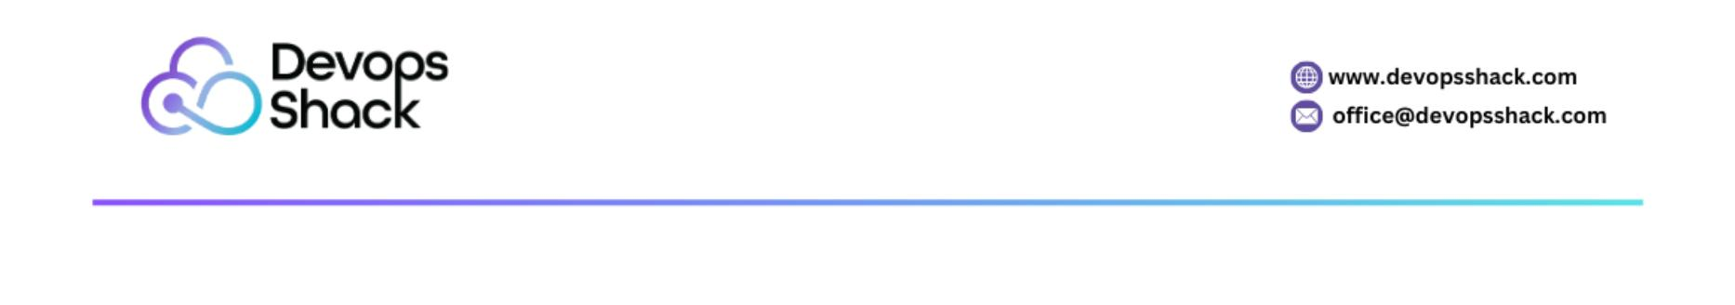

docker history <image_id>
4. Run problemaꢀc commands interacꢀvely in a base image:
docker run -it <base_image> /bin/bash
10. How do you persist data in a stateless Docker container?
Answer:
•
Use volumes to persist data:
docker run -v /host/data:/container/data <image_name>
Use named volumes:
•
docker volume create my_volume
docker run -v my_volume:/container/data <image_name>
•
For Docker Compose:
volumes:
app_data:
services:
app:
volumes:
- app_data:/container/data
10
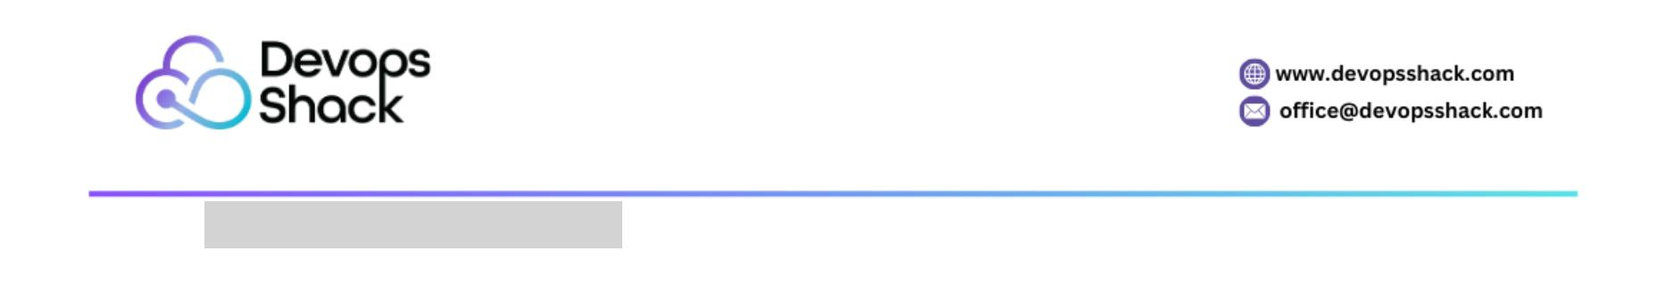

Advanced Conﬁguraꢀon and Mulꢀ-Container
Management
11. How do you connect a Docker container to mulꢀple networks?
Answer:
1. Create the networks:
docker network create network1
docker network create network2
2. Run the container and aꢂach it to one network:
docker run --network network1 --name my-container -d alpine
3. Connect the container to the second network:
docker network connect network2 my-container
4. Verify connecꢀons:
docker network inspect network1
docker network inspect network2
12. How do you set resource limits for a container?
Answer:
•
Use the --memory and --cpu opꢀons when running a container:
docker run --memory=512m --cpus=1 <image_name>
•
Example to limit:
o Memory to 512MB.
o CPU usage to 1 core.
For docker-compose:
•
version: '3.7'
services:
app:
11
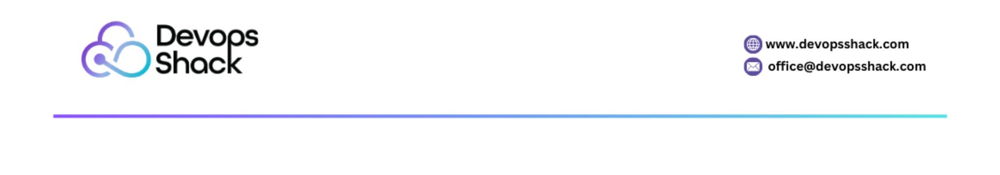

image: my-app
deploy:
resources:
limits:
memory: 512M
cpus: "1.0"
13. How do you share environment variables across mulꢀple containers?
Answer:
1. Use an .env ﬁle:
o Example .env ﬁle:
DB_USER=root
DB_PASSWORD=secret
o Reference in docker-compose.yml:
version: '3.7'
services:
app:
image: my-app
env_ﬁle:
- .env
2. Use a shared conﬁguraꢀon management tool like HashiCorp Vault or
AWS Secrets Manager for producꢀon environments.
14. How do you run mulꢀple versions of the same applicaꢀon in Docker?
Answer:
1. Use separate tags for each version:
docker run --name app-v1 my-app:v1
12
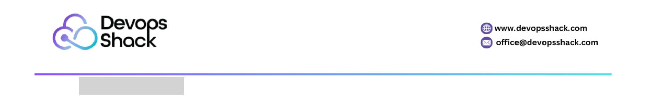

docker run --name app-v2 my-app:v2
2. Use diﬀerent ports for each version:
docker run -p 8080:80 my-app:v1
docker run -p 8081:80 my-app:v2
3. Alternaꢀvely, use Docker Compose with mulꢀple services:
services:
app_v1:
image: my-app:v1
ports:
- "8080:80"
app_v2:
image: my-app:v2
ports:
- "8081:80"
15. How do you troubleshoot high CPU usage in a Docker container?
Answer:
1. Idenꢀfy the problemaꢀc container:
docker stats
2. Inspect the running processes:
docker exec <container_id> top
3. Analyze the logs:
docker logs <container_id>
4. Proﬁle the applicaꢀon to detect boꢂlenecks.
5. Use strace or similar tools inside the container:
docker exec <container_id> strace -p <process_id>
13
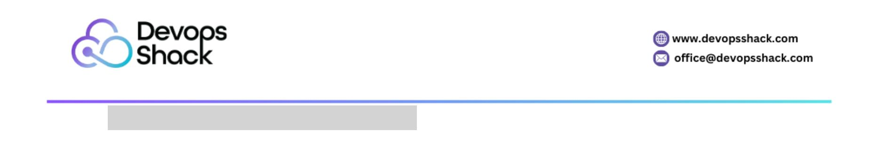

16. How do you build a mulꢀ-stage Dockerﬁle?
Answer:
•
Mulꢀ-stage builds opꢀmize image size by separaꢀng build and runꢀme
stages:
# Build stage
FROM node:16 AS builder
WORKDIR /app
COPY package.json .
RUN npm install
COPY . .
RUN npm run build
# Producꢀon stage
FROM nginx:alpine
COPY --from=builder /app/dist /usr/share/nginx/html
•
Build the image:
docker build -t my-app .
17. How do you run a container with limited network access?
Answer:
•
Use a custom Docker network with restricted rules:
docker network create --subnet=192.168.1.0/24 my-network
docker run --network my-network <image_name>
•
•
Use ﬁrewall rules on the host to restrict outgoing traﬃc.
Use --network none to completely isolate the container from the
network:
14


docker run --network none <image_name>
18. How do you roll back to a previous version of an image?
Answer:
1. Pull the previous version:
docker pull my-app:v1
2. Stop the current container:
docker stop <container_id>
3. Start a new container with the older version:
docker run --name app-v1 -d my-app:v1
19. How do you migrate data from one volume to another?
Answer:
1. Create a temporary container to copy data:
docker run --rm -v old_volume:/from -v new_volume:/to busybox sh -c "cd
/from && cp -r . /to"
2. Verify data in the new volume:
docker run --rm -v new_volume:/data busybox ls /data
20. How do you monitor logs across mulꢀple containers?
Answer:
1. Use the docker logs command for individual containers:
docker logs -f <container_id>
2. Use a centralized logging system like ELK stack or Fluentd.
3. Use Docker Compose with logging drivers:
version: '3.7'
services:
15
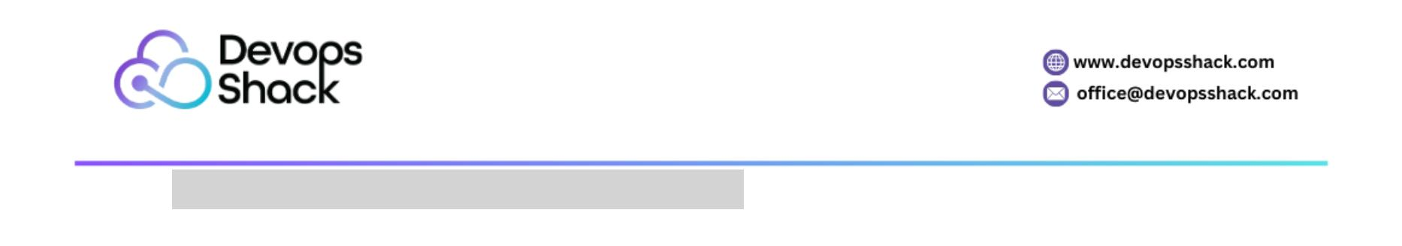

app:
image: my-app
logging:
driver: "json-ﬁle"
opꢀons:
max-size: "10m"
max-ﬁle: "3"
16
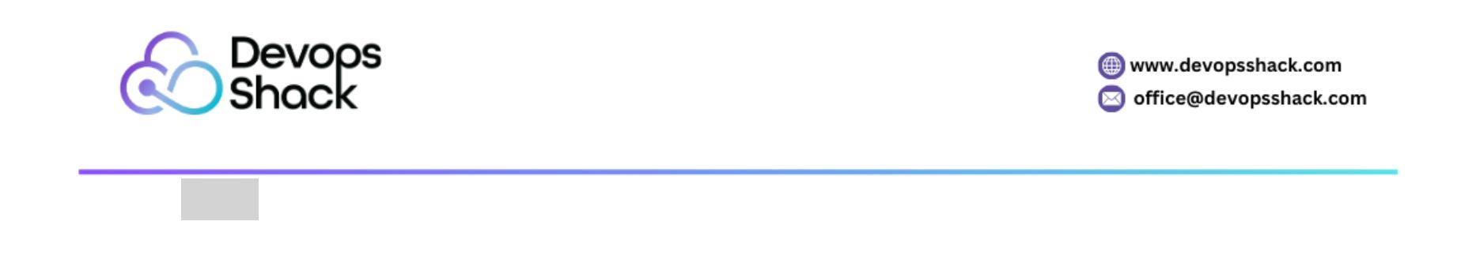

Network, Security, and Resource Management
21. How do you handle a Docker image that becomes outdated or bloated?
Answer:
1. Regularly clean up unused images:
docker image prune -a
2. Use a clean base image and build minimal layers:
o Start with a minimal base image like alpine.
o Avoid installing unnecessary packages.
3. Remove intermediate ﬁles in the Dockerﬁle:
RUN apt-get update && apt-get install -y curl && \
apt-get clean && \
rm -rf /var/lib/apt/lists/*
4. Automate rebuilding images with CI/CD pipelines to keep dependencies
up to date.
22. How do you troubleshoot a container that is unreachable on its published
ports?
Answer:
1. Verify container status:
docker ps
2. Check port mappings:
docker inspect <container_id> | grep "Ports"
3. Ensure the host port is not already in use:
netstat -tuln | grep <port>
4. Verify ﬁrewall rules and network policies on the host.
5. Test connecꢀvity using curl or telnet from the host to the container's
published port.
17
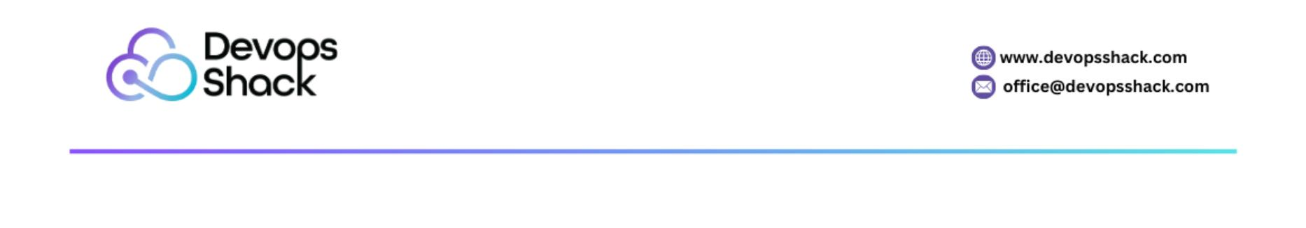

23. How do you conﬁgure logging for a Docker container?
Answer:
1. Use logging opꢀons when running a container:
docker run --log-driver json-ﬁle --log-opt max-size=10m --log-opt max-ﬁle=3
<image_name>
2. Conﬁgure logging in docker-compose.yml:
logging:
driver: "json-ﬁle"
opꢀons:
max-size: "10m"
max-ﬁle: "3"
3. Integrate with centralized logging systems like Fluentd or ELK by
specifying a logging driver.
24. How do you restart a container automaꢀcally with a delay between
retries?
Answer:
•
Use --restart policies with Docker Compose:
version: '3.7'
services:
app:
image: my-app
deploy:
restart_policy:
condiꢀon: on-failure
delay: 5s
18
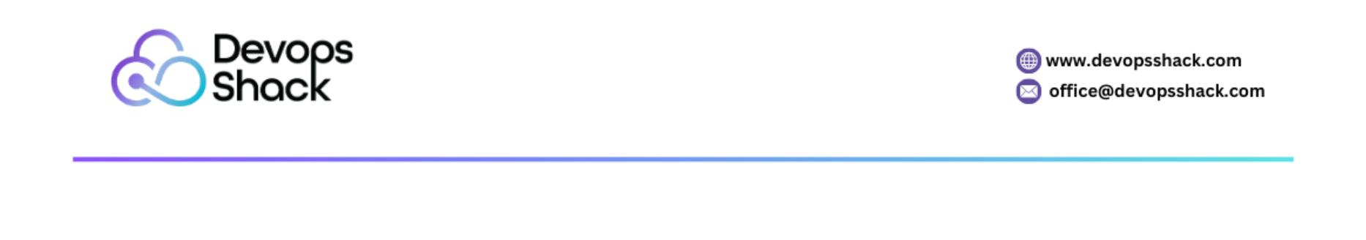

max_aꢂempts: 3
For Docker CLI:
•
docker run --restart on-failure:<max_aꢂempts> <image_name>
25. How do you prevent data loss when recreaꢀng a container?
Answer:
1. Use named volumes:
docker volume create my_data
docker run -v my_data:/app/data <image_name>
2. Backup the volume before recreaꢀng the container:
docker run --rm -v my_data:/data -v $(pwd):/backup busybox tar czf
/backup/data.tar.gz /data
3. Store conﬁguraꢀons in environment variables or conﬁguraꢀon ﬁles
mounted as volumes.
26. How do you manage mulꢀple versions of Docker Compose ﬁles for
diﬀerent environments?
Answer:
1. Create separate ﬁles for each environment:
o docker-compose.dev.yml
o docker-compose.prod.yml
2. Override the base conﬁguraꢀon using -f:
docker-compose -f docker-compose.yml -f docker-compose.prod.yml up
3. Use COMPOSE_FILE environment variable:
export COMPOSE_FILE=docker-compose.prod.yml
docker-compose up
19
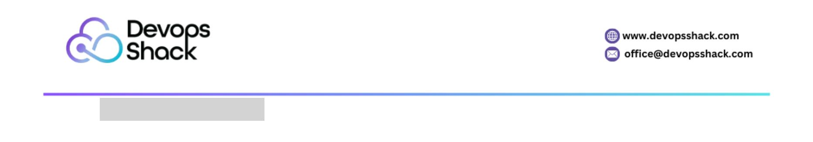

27. How do you scale a service in Docker Compose?
Answer:
1. Use the --scale opꢀon with docker-compose:
docker-compose up --scale app=5
2. Deﬁne scaling in the Compose ﬁle:
version: '3.7'
services:
app:
image: my-app
deploy:
replicas: 5
3. Ensure the applicaꢀon can handle mulꢀple replicas (e.g., stateless
design, shared storage).
28. How do you expose a Docker service to the internet securely?
Answer:
1. Use a reverse proxy like NGINX:
docker run -d -p 80:80 -p 443:443 nginx
2. Secure traﬃc with SSL/TLS using Let's Encrypt or self-signed cerꢀﬁcates.
3. Limit exposed ports:
docker run -p 8080:8080 --expose 8080 <image_name>
4. Implement ﬁrewall rules to restrict access.
5. Use a Docker network to separate internal and external traﬃc.
29. How do you inspect the ﬁlesystem of a running container?
Answer:
20
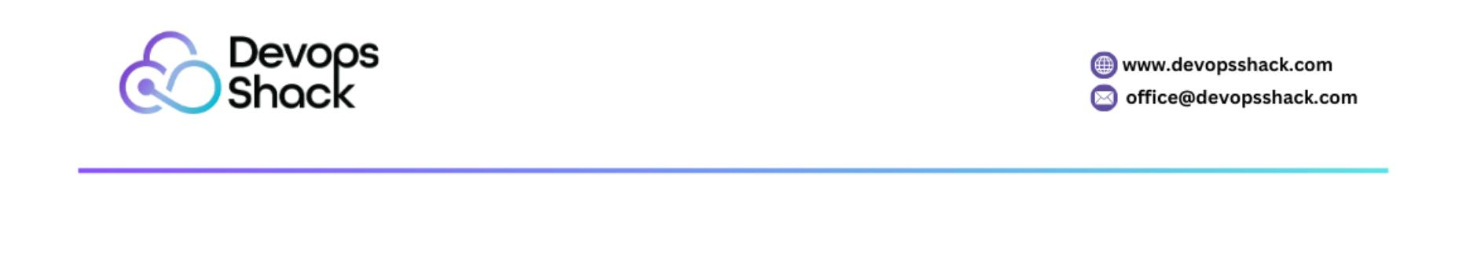

1. Use docker exec to start a shell in the container:
docker exec -it <container_id> /bin/bash
2. Explore the ﬁlesystem directly:
ls -al /path/to/directory
3. Mount the container's ﬁlesystem to the host:
docker cp <container_id>:/path/to/ﬁle /host/path
30. How do you clean up unused Docker objects (images, containers,
volumes, networks)?
Answer:
1. Remove stopped containers:
docker container prune
2. Remove dangling images:
docker image prune
3. Remove unused volumes:
docker volume prune
4. Clean up all unused objects:
docker system prune -a --volumes
Operaꢀonal Challenges and Opꢀmizaꢀon
31. How do you conﬁgure a container to use a speciﬁc DNS server?
Answer:
1. Use the --dns opꢀon when running a container:
docker run --dns=8.8.8.8 <image_name>
21
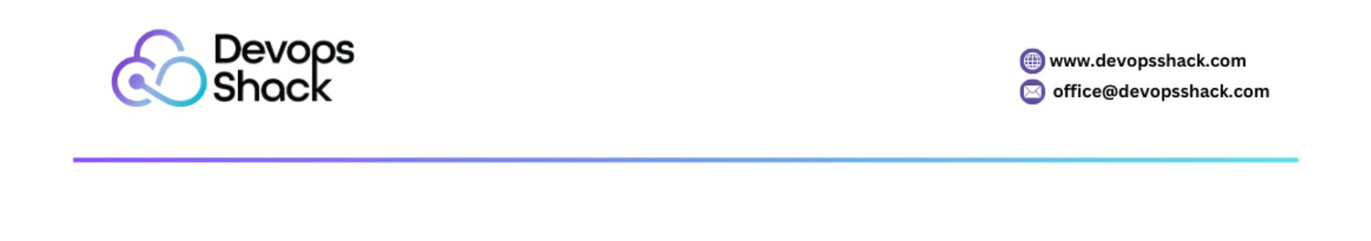

2. Conﬁgure DNS servers globally in /etc/docker/daemon.json:
"dns": ["8.8.8.8", "8.8.4.4"]
{
}
Restart the Docker service to apply changes:
sudo systemctl restart docker
3. Verify DNS conﬁguraꢀon in the container:
docker exec <container_id> cat /etc/resolv.conf
32. How do you restrict access to a container running on a speciﬁc IP address?
Answer:
1. Bind the container to a speciﬁc IP on the host:
docker run -p 192.168.1.100:8080:80 <image_name>
2. Use an overlay network and limit container-to-container communicaꢀon:
docker network create --subnet=192.168.1.0/24 my-network
docker run --network=my-network <image_name>
3. Apply ﬁrewall rules to restrict access to speciﬁc IPs.
33. How do you handle a situaꢀon where a container is consuming too much
memory?
Answer:
1. Set memory limits during container creaꢀon:
docker run --memory=512m <image_name>
2. Monitor container memory usage with docker stats:
docker stats <container_id>
3. Check logs for memory-related errors:
22
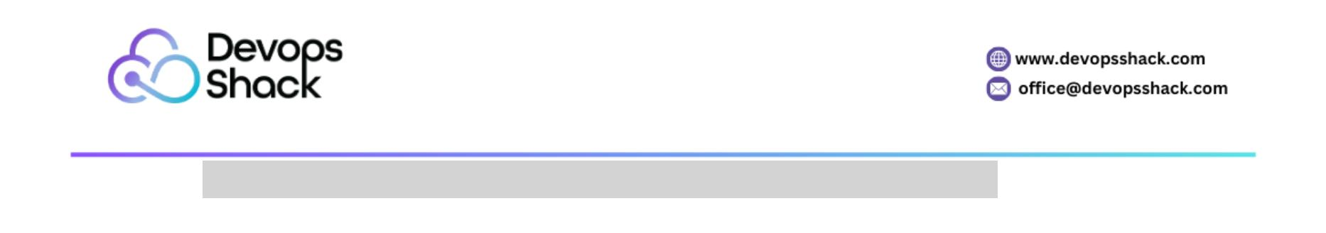

docker logs <container_id>
4. Opꢀmize the applicaꢀon code and reduce memory-intensive operaꢀons.
34. How do you run a container in detached mode and aꢁach to it later?
Answer:
1. Start the container in detached mode:
docker run -d <image_name>
2. Aꢂach to the container:
docker aꢂach <container_id>
3. Alternaꢀvely, use docker exec to open a new session:
docker exec -it <container_id> /bin/bash
35. How do you limit the number of processes inside a container?
Answer:
1. Use the --pids-limit opꢀon:
docker run --pids-limit=100 <image_name>
2. Conﬁgure this limit in docker-compose.yml:
version: '3.7'
services:
app:
image: my-app
deploy:
resources:
limits:
pids: 100
3. Verify the limit within the container:
23
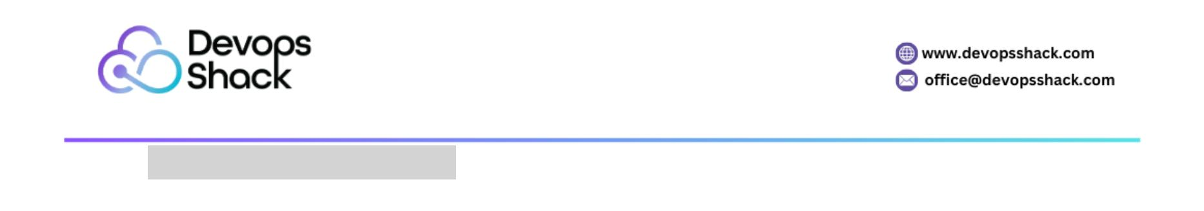

cat /proc/sys/kernel/pid_max
36. How do you restart a container with updated environment variables
without stopping the current one?
Answer:
1. Use docker update to modify the environment variables:
docker update --env NEW_VAR=value <container_id>
(Note: This works only for certain updates; restarꢀng is generally required for
env changes.)
2. Stop and start the container with new variables:
docker stop <container_id>
docker run -e NEW_VAR=value <image_name>
3. Use docker-compose to apply changes:
docker-compose up -d
37. How do you ensure a Docker container always starts on system boot?
Answer:
1. Use the --restart always policy:
docker run --restart always <image_name>
2. For docker-compose, deﬁne the restart policy:
version: '3.7'
services:
app:
image: my-app
restart: always
3. Enable Docker to start on boot:
sudo systemctl enable docker
24
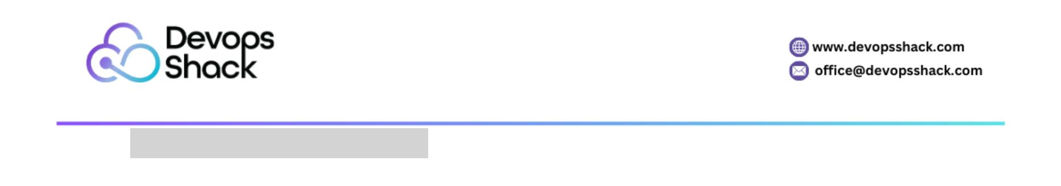

38. How do you secure a Docker container running a sensiꢀve applicaꢀon?
Answer:
1. Use non-root users:
RUN adduser --disabled-password appuser
USER appuser
2. Limit container capabiliꢀes:
docker run --cap-drop=ALL <image_name>
3. Enable read-only ﬁlesystem:
docker run --read-only <image_name>
4. Use secrets management tools for sensiꢀve data.
5. Scan the image for vulnerabiliꢀes using tools like Trivy.
39. How do you connect a container to a running database container?
Answer:
1. Use a shared Docker network:
docker network create my-network
docker run --network=my-network --name=db postgres
docker run --network=my-network my-app
2. Use the container name as the hostname:
o Example conﬁguraꢀon in the app:
DATABASE_HOST=db
DATABASE_PORT=5432
3. Test connecꢀvity from the applicaꢀon container:
docker exec <app_container_id> ping db
Advanced Scenarios, Security, and Deployment
25
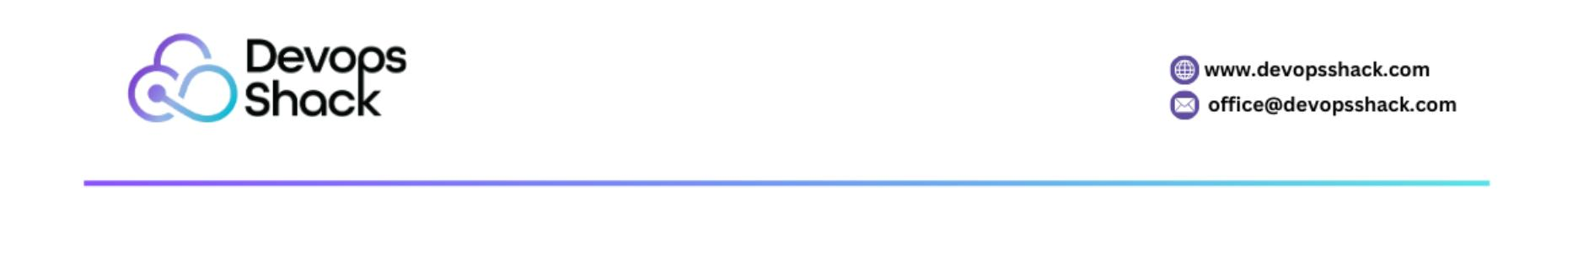

40. How do you handle image versioning for a CI/CD pipeline?
Answer:
1. Tag images with unique idenꢀﬁers:
docker build -t my-app:1.0 .
2. Use Git commit hashes or build numbers for tagging:
docker build -t my-app:$(git rev-parse --short HEAD) .
3. Automate the tagging and push in CI/CD pipelines:
docker build -t my-app:${CI_COMMIT_TAG} .
docker push my-app:${CI_COMMIT_TAG}
4. Use a latest tag for the most recent stable version.
41. How do you run a container in privileged mode, and why would you need
it?
Answer:
•
Privileged mode grants the container access to host resources, similar to
root access.
•
Run a container in privileged mode:
docker run --privileged <image_name>
•
Common use cases:
o Running Docker inside Docker (dind).
o Accessing hardware devices like USB or GPU.
Cauꢀon: Avoid using privileged mode in producꢀon due to security risks.
•
42. How do you manage mulꢀple containers with diﬀerent conﬁguraꢀons in
Docker Compose?
Answer:
1. Deﬁne separate services in the docker-compose.yml ﬁle:
26
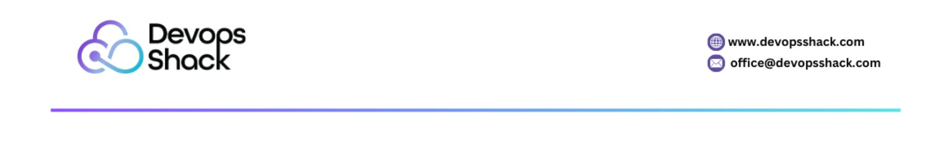

version: '3.7'
services:
app:
image: my-app
ports:
- "8080:8080"
environment:
- ENV=producꢀon
db:
image: postgres
environment:
- POSTGRES_PASSWORD=secret
2. Use mulꢀple Compose ﬁles for overrides:
docker-compose -f docker-compose.yml -f docker-compose.override.yml up
3. Pass environment-speciﬁc conﬁguraꢀons using .env ﬁles.
43. How do you debug slow container startup ꢀmes?
Answer:
1. Analyze logs:
docker logs <container_id>
2. Proﬁle the applicaꢀon startup process inside the container:
docker exec -it <container_id> /bin/bash
3. Check health checks in the Compose ﬁle or Kubernetes deployment.
4. Invesꢀgate dependencies like database or API latency.
44. How do you clean up exited containers automaꢀcally?
27
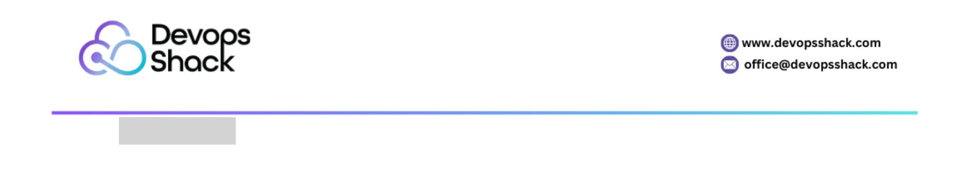

Answer:
•
Use the --rm opꢀon when starꢀng a container:
docker run --rm <image_name>
•
Remove all exited containers:
docker container prune
•
Automate cleanup with a cron job or CI/CD pipeline:
docker rm $(docker ps -a -q -f status=exited)
45. How do you implement health checks in a Docker container?
Answer:
•
Deﬁne health checks in the Dockerﬁle:
HEALTHCHECK --interval=30s --ꢀmeout=5s --retries=3 CMD curl -f
hꢂp://localhost:8080/health || exit 1
•
Use docker inspect to monitor health status:
docker inspect <container_id> | grep Health
For Docker Compose:
•
healthcheck:
test: ["CMD", "curl", "-f", "hꢂp://localhost:8080/health"]
interval: 30s
ꢀmeout: 5s
retries: 3
46. How do you back up and restore a Docker volume?
Answer:
1. Backup:
docker run --rm -v my_volume:/data -v $(pwd):/backup busybox tar czf
/backup/backup.tar.gz /data
28
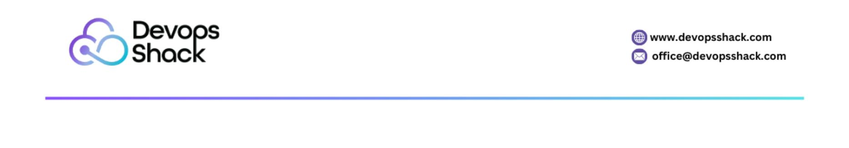

2. Restore:
docker run --rm -v my_volume:/data -v $(pwd):/backup busybox tar xzf
/backup/backup.tar.gz -C /data
3. Automate backups using a scheduled job or script.
47. How do you deploy a mulꢀ-ꢀer applicaꢀon using Docker Compose?
Answer:
•
Example docker-compose.yml for a mulꢀ-ꢀer app:
version: '3.7'
services:
frontend:
image: frontend-app
ports:
- "3000:3000"
depends_on:
- backend
backend:
image: backend-app
ports:
- "5000:5000"
depends_on:
- db
db:
image: postgres
environment:
- POSTGRES_PASSWORD=secret
•
Start the applicaꢀon:
29
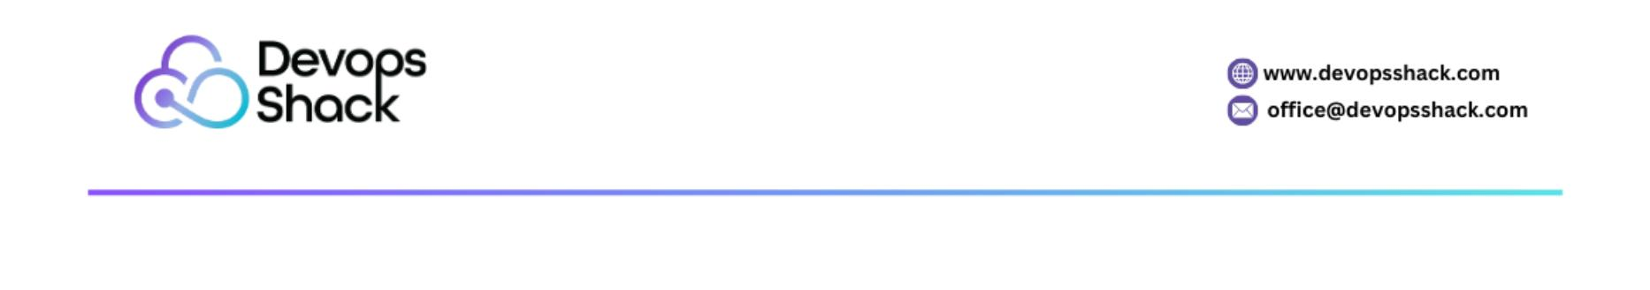

docker-compose up -d
48. How do you handle secrets securely in Docker Compose?
Answer:
1. Use the secrets feature in Compose version 3.1+:
version: '3.7'
services:
app:
image: my-app
secrets:
- db_password
secrets:
db_password:
ﬁle: ./db_password.txt
2. Ensure the secrets ﬁle is excluded from version control (.giꢀgnore).
3. Use external tools like HashiCorp Vault or AWS Secrets Manager for
producꢀon.
49. How do you run a container with GPU support?
Answer:
1. Install NVIDIA Container Toolkit:
sudo apt-get install -y nvidia-container-toolkit
2. Run the container with GPU support:
docker run --gpus all nvidia/cuda:11.0-base nvidia-smi
3. Specify GPU constraints:
docker run --gpus '"device=0,1"' <image_name>
30
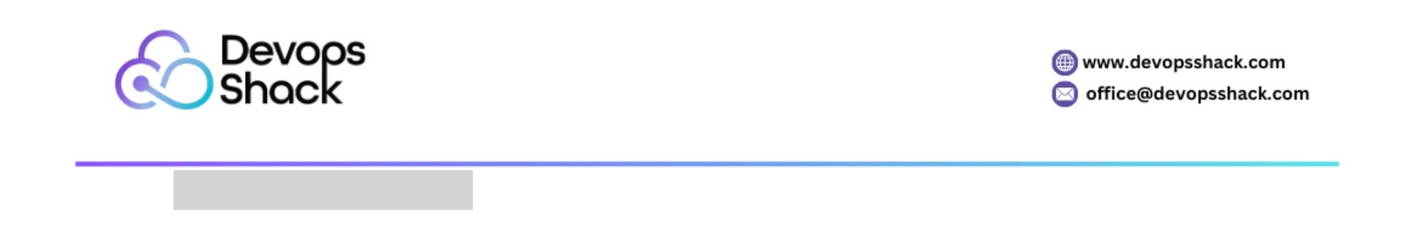

50. How do you secure Docker images before deployment?
Answer:
1. Use tools to scan for vulnerabiliꢀes:
trivy image <image_name>
2. Minimize the image size using smaller base images like alpine.
3. Avoid embedding secrets in the image.
4. Implement mulꢀ-stage builds to exclude unnecessary ﬁles:
FROM builder AS build-stage
# Build applicaꢀon
FROM alpine AS runꢀme
# Copy only necessary arꢀfacts
COPY --from=build-stage /app /app
5. Sign images using Docker Content Trust (DCT):
export DOCKER_CONTENT_TRUST=1
Conclusion
31
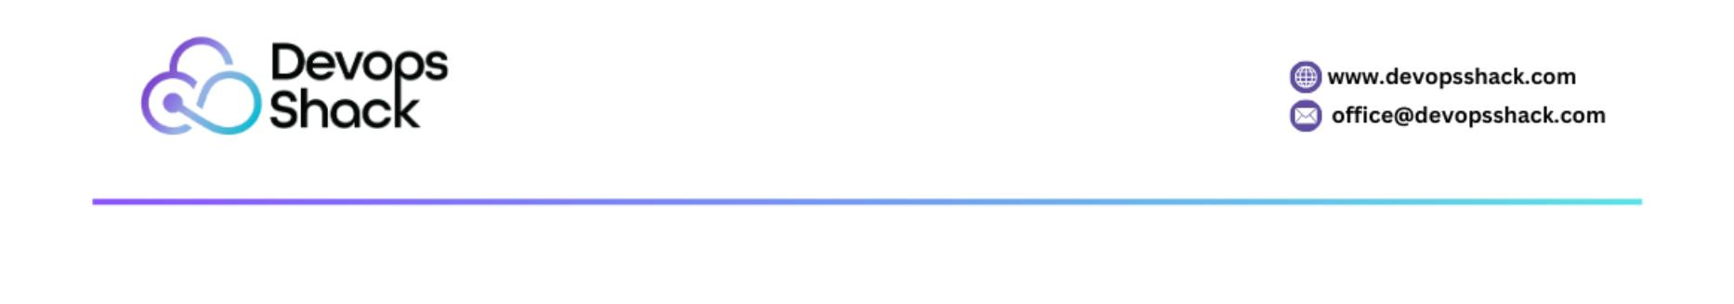

Docker has revoluꢀonized the way applicaꢀons are built, deployed, and
managed, oﬀering unparalleled ﬂexibility and consistency in soﬅware
environments. However, eﬀecꢀvely leveraging Docker requires not only a solid
understanding of its core concepts but also the ability to address real-world
challenges that arise during development, deployment, and maintenance.
This collecꢀon of 50 scenario-based quesꢀons and answers provides a
comprehensive guide to navigaꢀng these challenges. From debugging failing
containers to implemenꢀng advanced security measures and scaling mulꢀ-ꢀer
applicaꢀons, each scenario oﬀers pracꢀcal insights and acꢀonable soluꢀons.
These scenarios are not just theoreꢀcal; they reﬂect common issues faced by
developers, DevOps engineers, and system administrators in real-world
environments.
By mastering these scenarios, you can:
•
•
•
Build a deeper understanding of Docker’s features and best pracꢀces.
Enhance the eﬃciency and security of your containerized applicaꢀons.
Solve complex issues conﬁdently and opꢀmize workﬂows for beꢂer
performance.
Docker conꢀnues to play a pivotal role in modern soﬅware engineering, and
staying prepared for its challenges is key to maximizing its potenꢀal. Use this
guide as a reference to reﬁne your skills and ensure your Docker deployments
are reliable, secure, and producꢀon-ready. With the knowledge gained, you are
beꢂer equipped to tackle any Docker-related scenario, making you a valuable
asset in any containerized applicaꢀon development or DevOps environment.
32
